|  |  |
| --- | --- |
| University of Leicester logo | **MA1254 – Business challenge**  *Zhang Xunge, Sun Yingzhe, Zhao Jihang, Sun Jiajun*  *Group 17* |

**Consulting for Belvoir Dairy Limited**

Problem description:

Belvoir Dairies Limited (BDL) is a producer of high-quality cheese for specialist cheese shops, delicatessens and similar outlets. It operates two dairies on the edge of the Vale of Belvoir (pronounced bee-vər) in North East Leicestershire, and it produces three types of cheese, Blue Belvoir, White Belvoir, Red Belvoir.

The company has invited us to examine BDL’s operations and suggest improvements.

**Analysis:**

**Task 1**: BDL’s operations:

In the word document, BDL has provided us some operation and judgement information. Although there is not enough evidence to estimate the operation of whole company and give a full commercial report, we can also analyse and find out whether there are unreasonable or contradict operations. What we can change or adjust about BDL’s operations are:

1. The target levels of sales;
2. The additional amount of fresh milk;
3. The proportion of allocated cost of plants.

Currently, BDL collects milk from a local co-operative of dairy farms for 12 million litres a year. Thus, the expected output of a whole year is about 1200*t* cheese, which is equal to total target of BDL.

**Conclusion 1.** The current target levels of sales are reasonable.

BDL’s Commercial Director believes it should be possible to purchase an additional 3 million litres a year from farms further afield. In order to make full use of these milk so that cheese will not be produced from the out-of-date milk, the overall efficiency of plant should increase by 3 / 12 = 25%, thus, the current efficiency of whole plant should not be greater than 100% / (1+25%) = 80%.

From the document, both plants are operating at about 80% capacity.

**Conclusion 2.** The additional 3 million litres milk is reasonable.

From the *Operations* part, we can acknowledge that the proportion of the planning production purposes of three cheese of Upper and Lower plant. Firstly, the red cheese can be only produced in Lower plant, thus the total produced amount of Lower plant is 450 / 60% = 750*t*, and Upper plant’s is 1200 – 750 = 450*t*.

*Note*: In the following part, the order of three kind of cheese is blue: white: red.

Therefore, we can compute the exact amount of every categories of cheese, that is, Upper 247.5: 202.5 and Lower 187.5: 112.5: 450, average to 52 weeks, they are, Upper 4.76: 3.89 and Lower 3.61: 2.16: 8.65. Before we calculus the allocated cost of two plants, we need to get the unit cost of cheese. In the next part of this report, we will analyse the relationship between unit cost and produced amount. At here, the result will be used beforehand. The unit costs are Upper £7.90: £6.57 and Lower £9.30: £8.31: £7.43. Hence, the proportion of cost associated with planning proposes should be Upper 59.5%: 40.5% and Lower 30.0%: 15.4%: 54.6%.

According to the *Finance* part from document, the proportion of allocated cost are Upper 60%: 40% and Lower 30%: 25%: 45%.

**Conclusion 3.** The proportion of allocated cost of Upper plant is reasonable, but Lower plant’s is not, the cost of white should be decreased by 9.6% and the cost of red should be increased by 9.6%.

From above, we can conclude that the entirely operation for BDL is reasonable and great and only the allocated cost of Lower Plant needs a little bit adjustment. In the next part, we will give some improvement methods.

**Task2**: Improvement method

In this part, we will mostly focus on the data from the attached spreadsheet and word document, then analyse the relationship in them. Furthermore, giving an improvement plan.

Firstly, we will solve the relationship, as mentioned above, between cheese produced amount and sales price. Before doing data fitting, there is no harm in supposing that the relationships of three kinds of cheese are similar, since that the procedures of them are similar. By printing the plot of amounts and prices in *Rstudio*, we can roughly describe the relationship between them. As an example, we choose the white cheese produced by Upper Plant (figure 1). From a general view, if we use the linear model to fit these data, (y represents unit cost and x represents produced amount)

$$y= ax+b$$

It seems to be unreasonable, as the endpoints and midpoints are all a little bit far from the line (figure 2). Thus, we can use a non-linear model of exponent

$$y=ae^{bx}+c$$

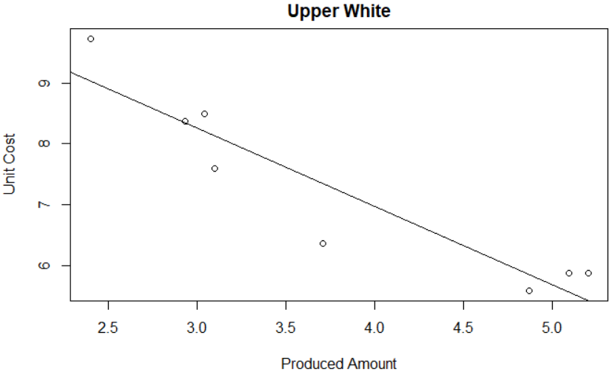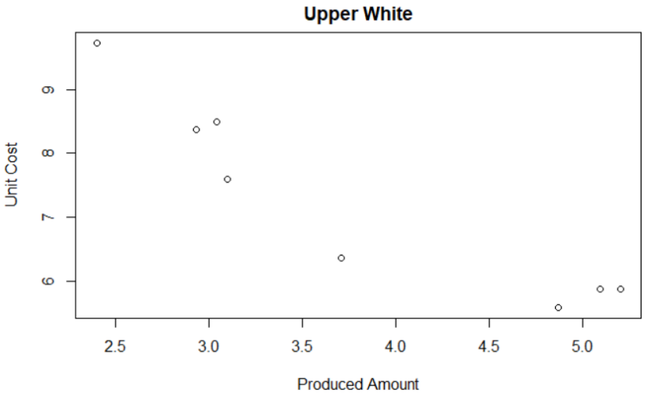to fit the data. The fitting result is shown in figure 3. It is clear that the fitting is great, in other word, we can use this model to estimate the relationship between produced amount and sales price.

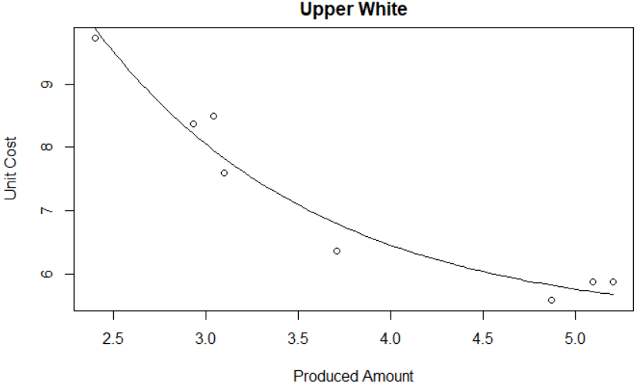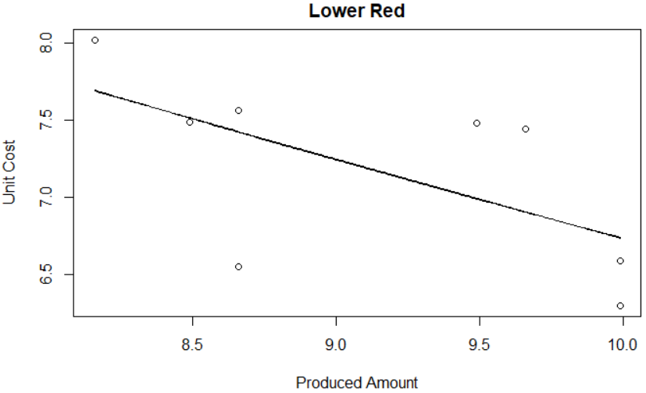 Figure 1 Figure 2

Figure 3 Figure 4

Similarly, we do the same data fitting to all kinds of cheese of all plants. Limited to the shortage of page, the figure will not be shown, and the fitting functions are at the *Technical formulas* part.

One fact needs to be noticed is that, the red cheese from Lower Plant cannot be fitting with the above exponential model, since that the scatters are really far away from each other. Actually, we do not know whether the red cheese indeed follows the above exponential model since “the relationships of three kinds of cheese are similar” is merely a assumption. Thus, we need more data to find out the exact model that red cheese follows. In this case, we can only use the simplest linear model to estimate the value of the point (figure 4).

From above, we can conclude that, the unit cost decreases as the produced amount increases. Thus, in order to reduce the production cost, one efficient method is to concentrate the production.

Before continuing to analyse and give a concentration plan, we will discuss whether it is more profitable to produce more cheese.

According to BDL’s Sales Department, only the additional production of blue cheese is profitable and they give us some discrete data of the relationship the sale amount and the price. Similarly, as above data fitting, we can find that “sale amount – price” follows the above exponential model, thus, the relationship of “price – sale amount” is a logarithm model, that is: (y represents price and x represents sale amount)

$$y=-\frac{1}{0.26}\ln{\frac{x-100.22}{5827.93}}$$

Additional production needs additional milk. The amount of addition milk BDL can get is 3 million litres, that is, 300*t* of cheese. Thus, the maximal amount of blue cheese is 750*t*.

The function of profit (*p*) is:

$$p=xy-0.4\left(x-450\right)=-\frac{x}{0.26}\ln{\frac{x-100.22}{5827.93}}-0.4x+200$$

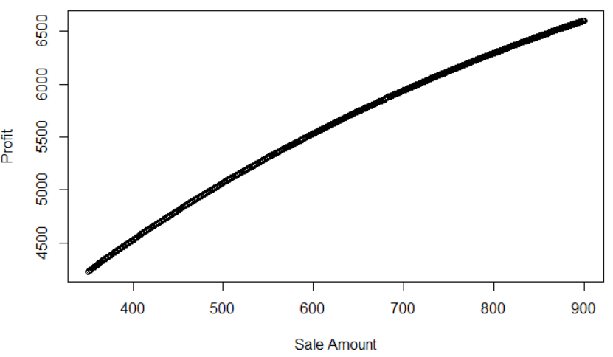

Therefore, it is profitable to produce as much blue cheese as we can, that is 750t.

To conclude that, we have got an improvement plan, concentratedly producing 750*t* blue cheese, 300*t* white cheese and 450*t* red cheese in 52 weeks.

To begin with easier one, red cheese. The red cheese can only be produced by Lower Plant. To concentrate on red cheese, the maximal amount of Lower Plant can produce in one week is 750 / 80% / 52 = 18.03*t*. Thus, it needs 450 / 18.03 = 25 weeks to produce the annual target of red cheese. Hence, there remains 52 weeks of Upper Plant and 27 weeks of Lower Plant to produce the blue and white cheese. Importantly, from the model of the unit cost, we find that it is cheaper to produce white cheese in Lower Plant, while the unit cost of blue is roughly the same.

Therefore, we need to concentrate the white cheese into the Lower Plant.

Since that the blue cheese and white cheese can only stay fresh for 2 weeks, the better plan is to produce blue and white one should launch every other week. Specially, in Christmas-production weeks (weeks include Oct 23rd and Oct 16th), plants can continuously produce the blue and white cheese to meet the seasonal addition order. Assume that increasing trend is 100%, then the production weekly plans are similar in Christmas-production weeks. Hence, the blue and white cheese should be produced similarly in 27 weeks. The production of white will use $\frac{300}{750/80\%}=32\%$ capacity of Lower Plant. Assume that Upper Plant produce t% blue cheese, and we can express the total cost of the blue cheese as:

$$\left(792.23e^{-1.60×\frac{250t}{9}}+7.51\right)t+\left(22.79e^{-0.51×\frac{250\left(1-t\right)}{9}}+5.69\right)\left(1-t\right)$$

By using Solver, the above terms get the minimum at 18.1%.

However, Lower Plant needs to produce

$81.9\%×\frac{750}{27}=22.75 t$ > $\frac{750/80\%}{52}\left(1-32\%\right)=12.26 t$

Therefore, in one week, Lower Plant should produce 12.26 t blue cheese and Upper Plant should produce $\frac{750/80}{52}-12.26=5.77 t$ blue cheese.

**Recommendation:**

BDL’s operations:

Overall great, but need to adjust the proportion of allocated cost of Lower Plant from 30%: 25%: 45% to 30.0%: 15.4%: 54.6%.

Improvement:

In Christmas-production and odd weeks, Upper Plant produces 5.77*t* blue cheese and Lower Plant produces 12.26*t* blue cheese and 11.11t white cheese*.*

In even weeks except Christmas-production weeks, Upper Plant does not produce cheese and Lower Plant produced 18.03*t* red cheese.

**Technical formulas:**

The function of data fitting model: (x represents produced amount and y represents sales price)

Blue cheese from Lower Plant:

$$y=22.7926e^{-0.5104x}+5.6850$$

White cheese from Lower Plant:

$$y=365.765e^{-2.244x}+5.438$$

Blue cheese from Upper Plant:

$$y=792.2345e^{-1.5955x}+7.5077$$

White cheese from Upper Plant:

$$y=34.2244e^{-0.8310x}+5.2221$$

Red cheese from Upper Plant:

$$y=-0.5199x+11.9293$$